IAM (Identity and Access Management)’

Create User Groups (DevOps)– Attach policies (EC2Full Access)

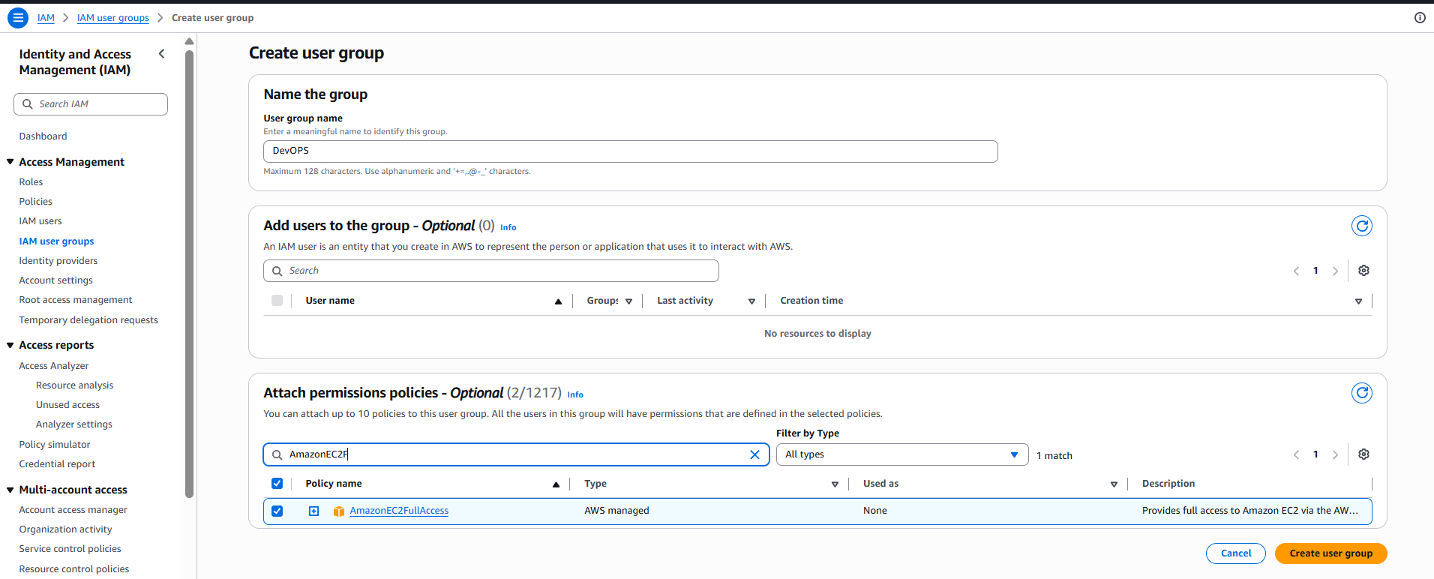

Attach policies (IAM Full Access)
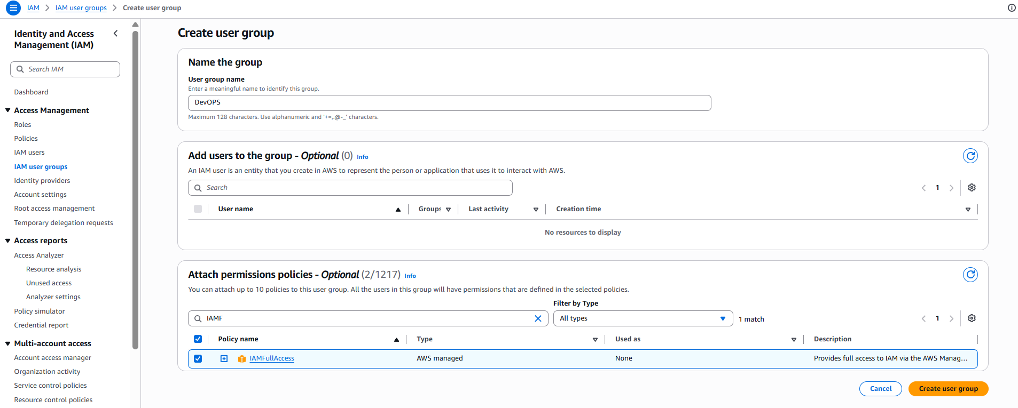
IAM User -Create User (User ID (Testing_User1))

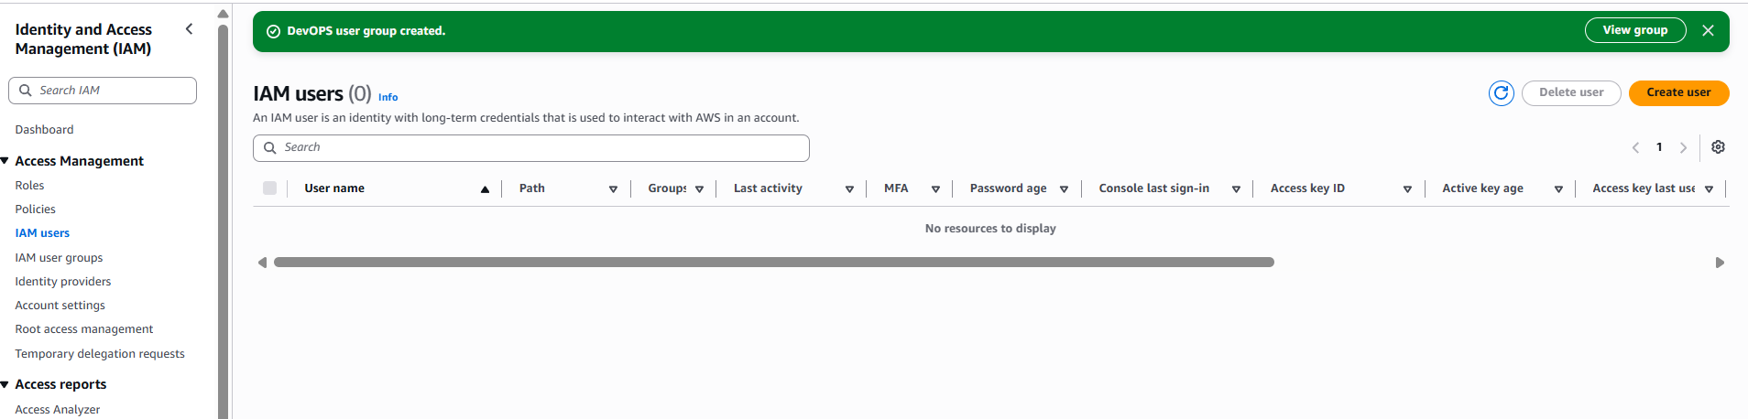

- Specify User details
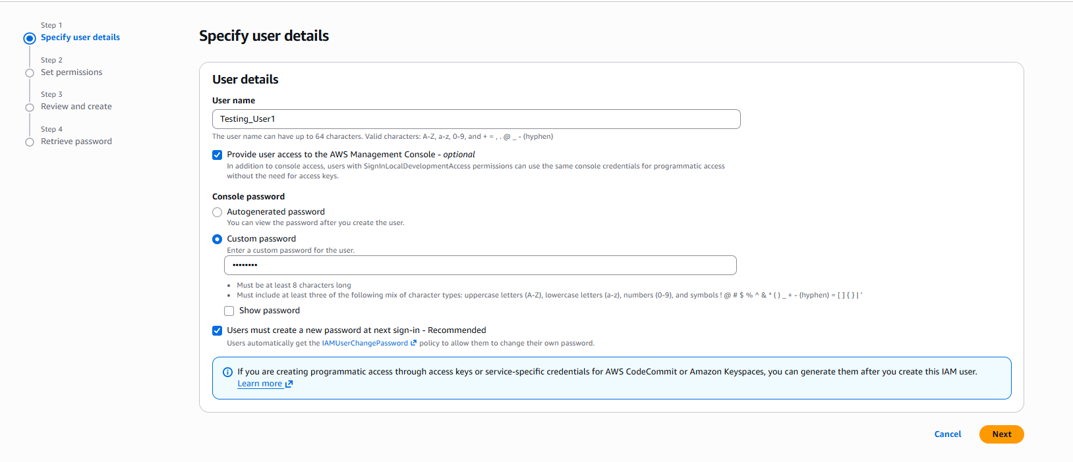

- Permission Choose user group
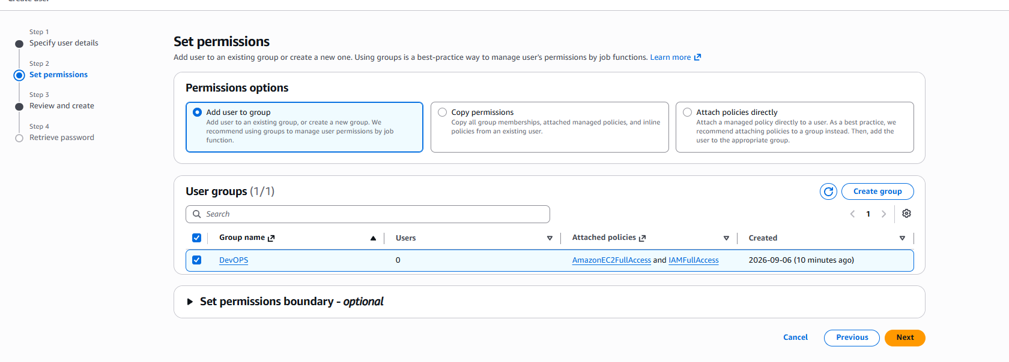

- Review the User Creation Click Create User.
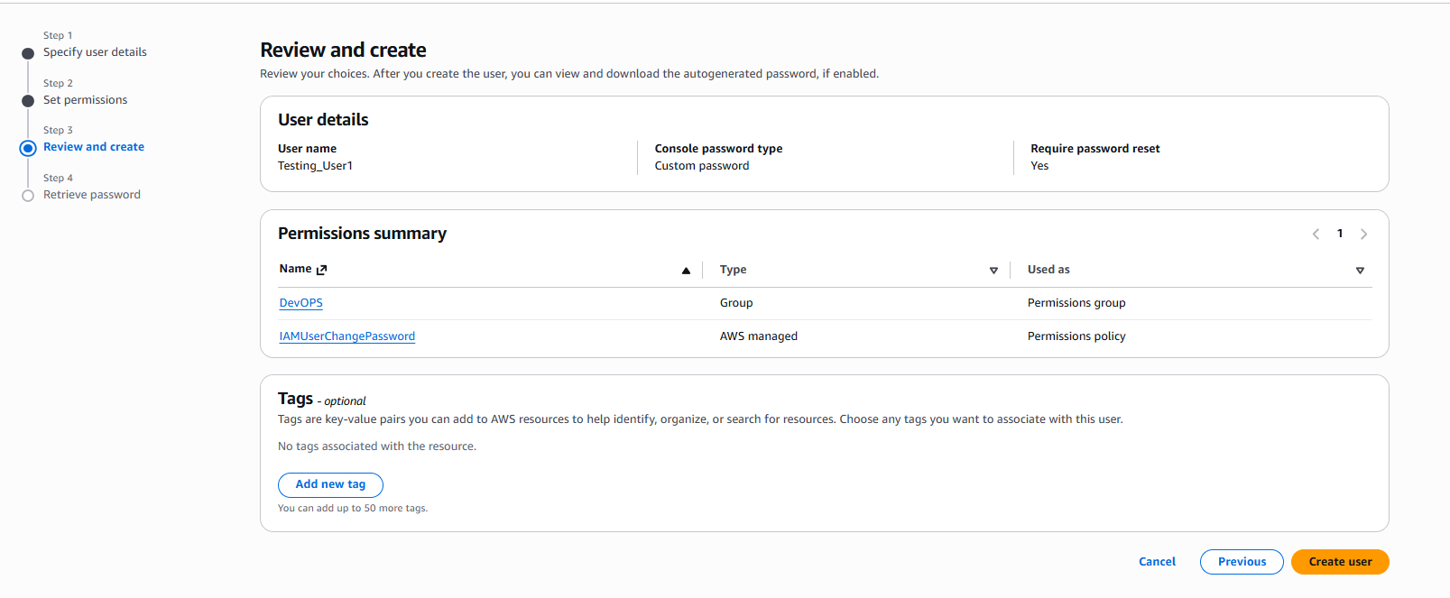

- Retrieve Password and Download .csv file

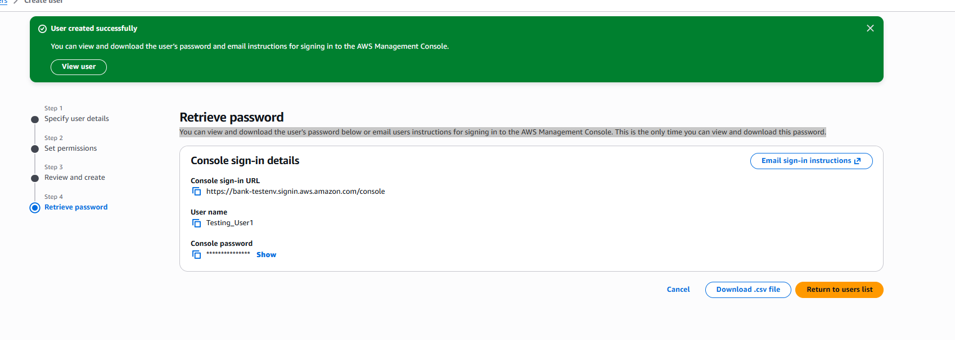

IAM USER LOGIN
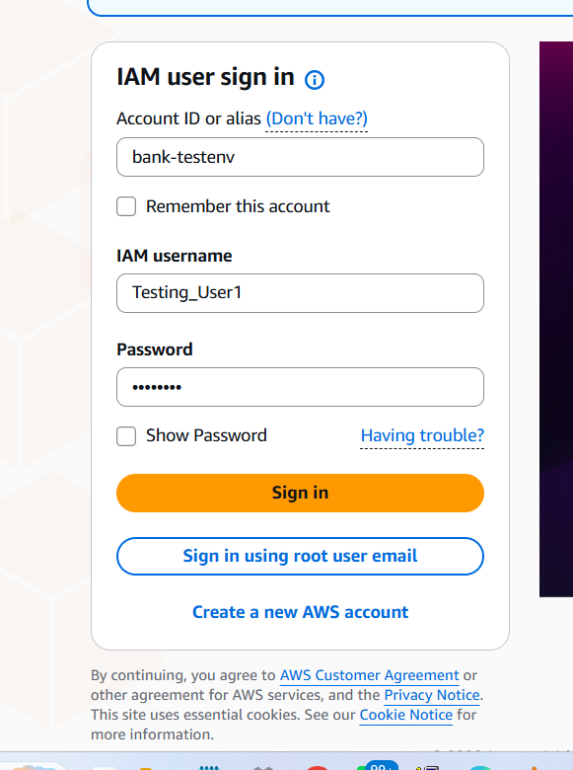

IAM USER - Change password permission
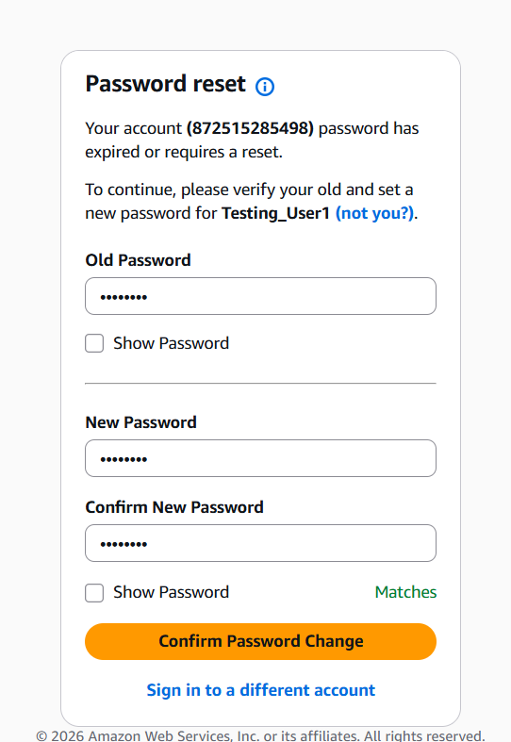
IAM User - S3 Permission Denied
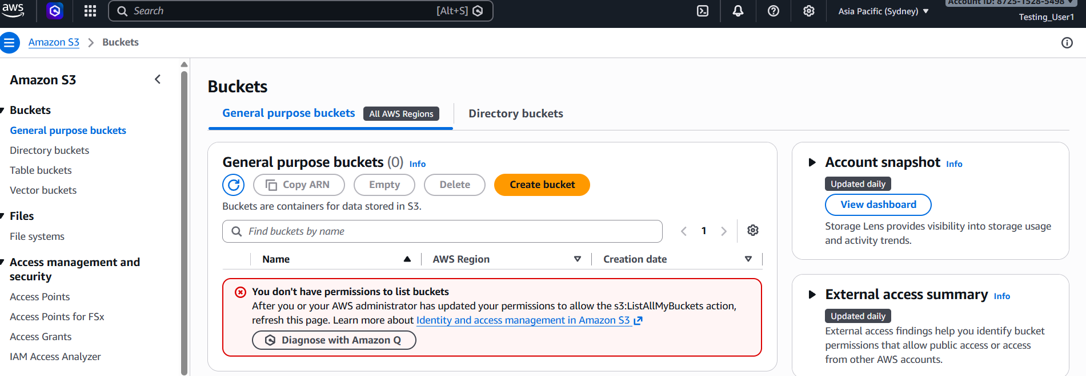

Root-User – Give Specify policy permission TO S3 List
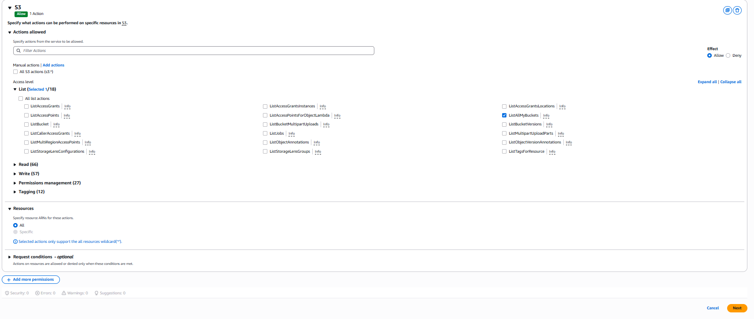

Root User Create and Review (Name: (IAM_Policy01)) Policy Creation.
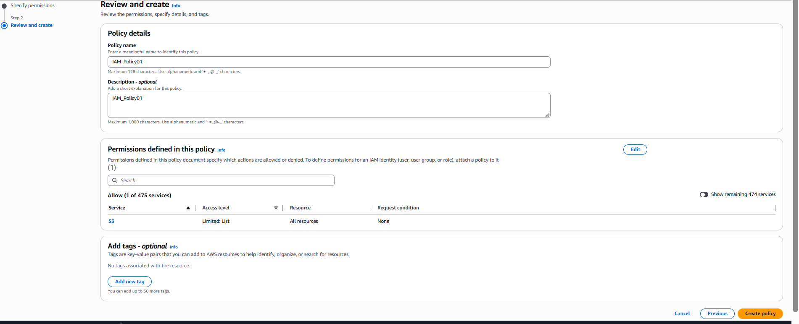

Add permission to User ID (Testing_User1)
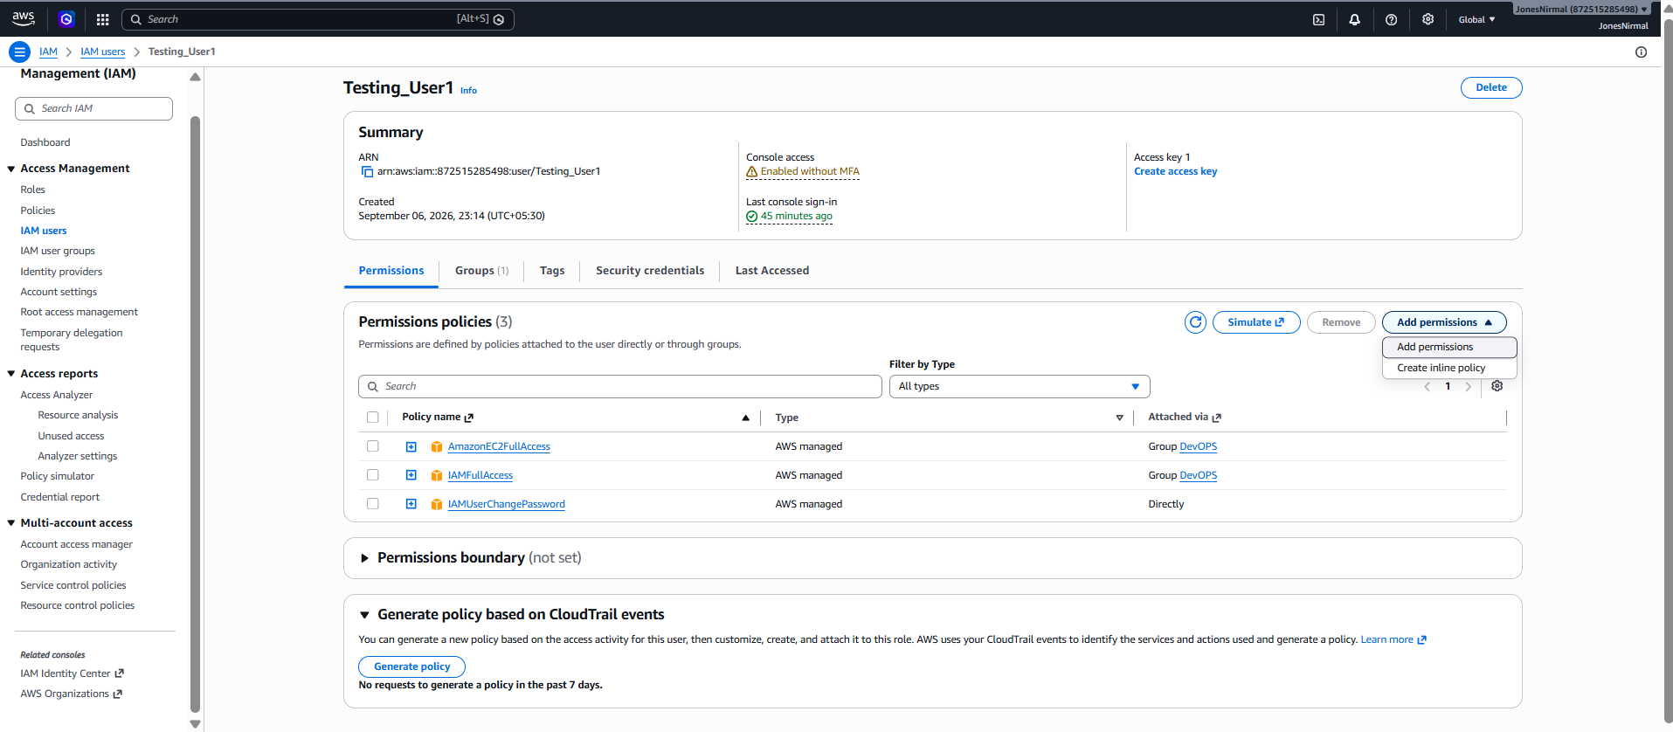
Add permission policy Attach Policy Directly Choose the IAM Policy
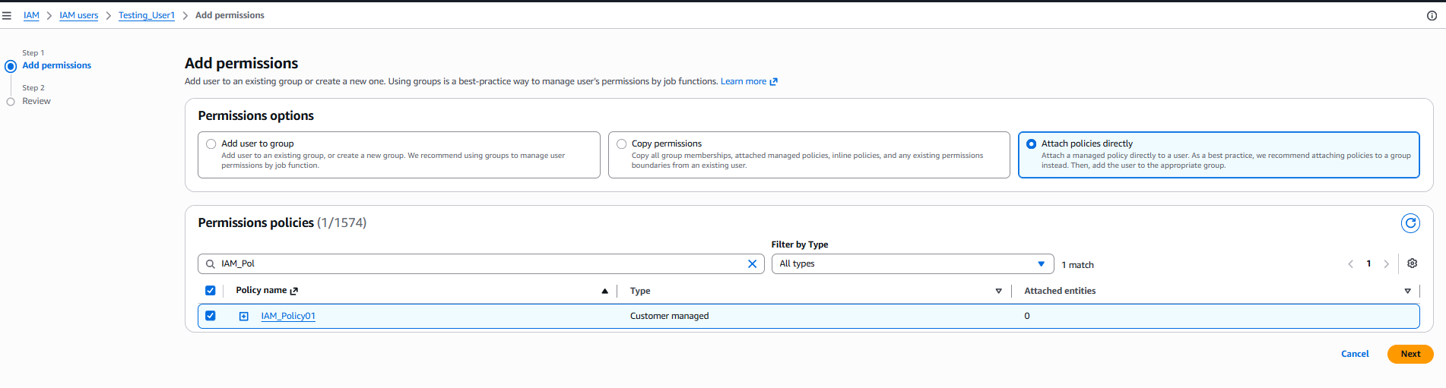
Now IAM User have view the S3-Bucket (Permission granted)
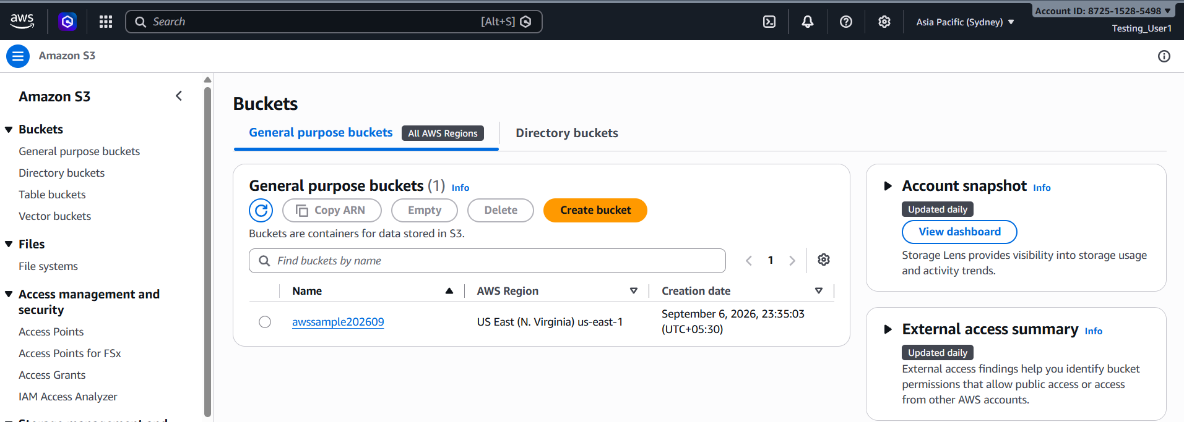

IAM User Can’t view the S3 Objects (Permission Denied)
